|  |
| --- |
|  |
| TEAM RYMSS |
|  |
| Project for operations with mathematical sets |

November, 2020

Table of Contents

1. Autors 1

2. Summery 2

2.1 Goals 2

2.2 Main stages of realization 2

2.3 Level of difficulty main problems during realization 2

2.4 Diagram 2

3. Description of the functions used 3

3.1 Purpose  3

3.2 Arguments 3

3.3 Returned value 3

# Autors

* ***Radina Velichkova***
* Scrum trainer
* [RVVelichkova18@codingburgas.bg](mailto:RVVelichkova18@codingburgas.bg)
* ***Yoana Stoyanova***
* Front-end developer
* [yistoyanova18@codingburgas.bg](mailto:yistoyanova18@codingburgas.bg)
* ***Stanislav Todorov***
* C++ developer
* [SATodorov18@codingburgas.bg](mailto:SATodorov18@codingburgas.bg)
* ***Magdalena Omayska***
* C++ developer
* [miomayska@codingburgas.bg](mailto:miomayska@codingburgas.bg)
* ***Stefan Ganchev***
* Code checker
* [SPGanchev18@codingburgas.bg](mailto:SPGanchev18@codingburgas.bg)

# 2. Summery

## 2.1 Goals

The goal of our project is to create a program that calculates all mathematical operations related to sets. They are subsets, set difference, union, intersection and Cartesian product.

## 2.2 Main stages of realization

First stage – planning. The first stage of the realization of our project was to create a meeting and discus the different roles and tasks that we had to do.

Second stage – realization. When the tasks and roles were clear we started to work on them. We began writing the project code and making the presentation and documentation that explain it in more detail.

Third stage – presentation. The final stage is to submit in front of the judges the finished product.

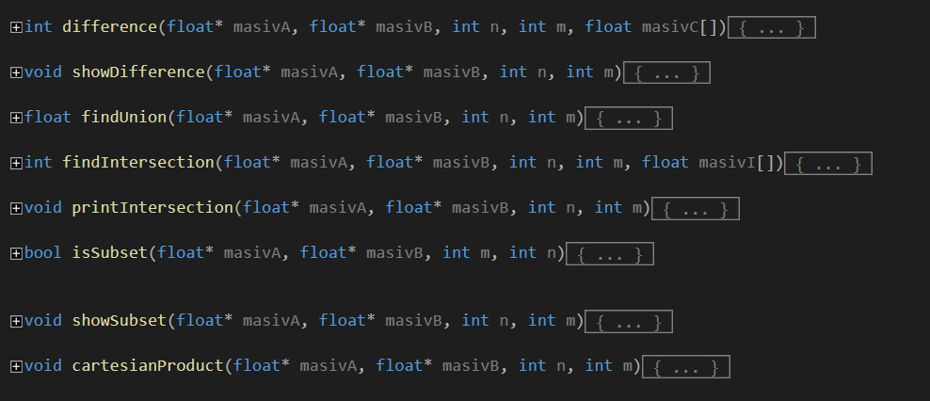

## 2.3 Level of difficulty main problems during realization

Writing the code for the program was the most challenging part of completing our project. We had a few misunderstandings along the way about the functionality of various sections of the code. We had a few malfunctions with GitHub as well, but we managed to overcome everything and finish our tasks at the end.

## 

## 2.4 Diagram

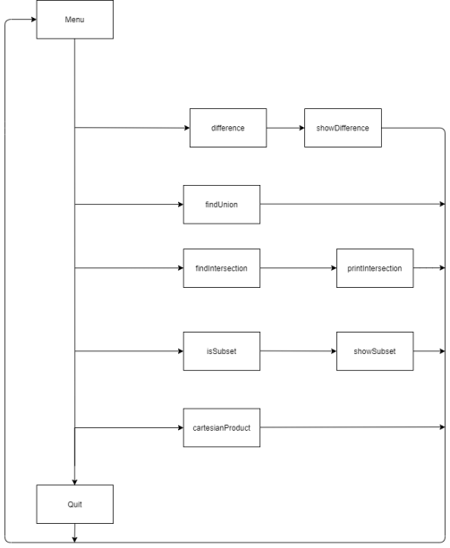

# 3. Description of the functions used

|  |  |  |  |
| --- | --- | --- | --- |
| Function name | Purpose | Arguments | Returned value |
| difference() | Function for finding the difference of sets A and B | float* masivA, float* masivB, int n, int m, float masivC[] | INT |
| ShowDifference() | Function for displaying the difference of sets A and B | float* masivA, float* masivB, int n, int m | VOID |
| findUnion() | Function for finding the union of sets A and B | float* masivA, float* masivB, int n, int m | FLOAT |
| findIntersection() | Function for finding the intersection of sets A and B | float* masivA, float* masivB, int n, int m, float masivI[] | INT |
| printIntersection() | Function for displaying the intersection of sets A and B | float* masivA, float* masivB, int n, int m | VOID |
| isSubset() | Function for finding if the set A is a subset of B | float* masivA, float* masivB, int m, int n | BOOL |
| showSubset() | Function for displaying if the set A is a subset of B | float* masivA, float* masivB, int n, int m | VOID |
| cartesianProduct() | Function for finding the Cartesian product of sets A and B | float* masivA, float* masivB, int n, int m | VOID |
| secondMenu() | Function for displaying the different operations with mathematical sets | float* masivA, float* masivB, int n, int m | BOOL |
| mainMenu() | Function for displaying the main menu of the program and inserting the values of the sets | float* masivA, float* masivB, int n, int m | BOOL |